Conda Tutorial [ft. Patrick Liu & Erik Rozi]

1. Download anaconda bash script in tmp folder on Atlas home directory

cd /atlas/u/<CSID>

mkdir tmp

cd tmp

curl -O <https://repo.anaconda.com/archive/Anaconda3-2020.11-Linux-x86_64.sh>

For most recent version, download from https://www.anaconda.com/distribution/

2. Validate the checksum using the Anaconda website if possible

sha256sum Anaconda3-2020.11-Linux-x86_64.sh

3. Run the installer (type yes and ENTER when prompted)

bash Anaconda3-2020.11-Linux-x86_64.sh

4. Follow the terminal instructions to accept license terms and confirm installation location



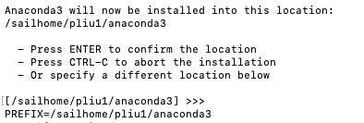

5. Be patient. Very patient.

6. Scream for help in the computer_cluster channel on Slack if necessary

7. Activate installation using

source ~/.bashrc

8. Test installation using

conda list

9. Remove tmp folder

cd ..

rm -R tmp

10. Set up conda environment (replace version-num with python version, or omit =version-num for default. As of this tutorial, default is python 3.9.2).

conda create --name name-of-environment python=version-num

11. Activate environment

conda activate name-of-environment

12. Install packages needed for project

conda install name-of-package

13. Deactivate environment when finished coding

conda deactivate

Installation help received from

<https://www.digitalocean.com/community/tutorials/how-to-install-anaconda-on-ubuntu-18-04-quickstart>